Realme C21

Type of device: Mobile
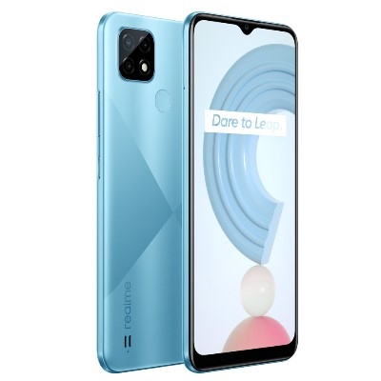

Actual Display Size : 6.5 inches
Button Type : Touchscreen
Operating System : Android
Version Number : Realme UI 1.0 (Based on Android 10)
Network Capability : 3G,4G
Year of Release : 2021
Average Price : $199 as of 09 06 2021

Accessibility Features:

Cognitive
- Additional Instructions
- Copy and Paste
- GPS
- Photo Telephone List
- Screen Timeout Disabled
- Simple Instructions
- Simple Reminders
- Simplify Display
Voice Notes

Hearing Impairment and Deaf
- Allows for sign language communication
- Bluetooth or Wi-Fi
- Closed Captioning
- Front Facing Camera
- Text Messaging/SMS
- Vibrating Alerts - Adjustable
- Video Communications - Two-way
Visual Alerts - Incoming Calls

Vision
- Battery Alert - Audible
- Bluetooth or Wi-Fi
- Braille Display Support
- Brightness Adjustable
- Dictation / Speech-to-Text
- Personalised Shortcuts
- Power Cue
- Screen Magnifier
- Screen Reader
- Text Size Adjustable
- Voice Control /Personal Assistant
Voiced Menus

Speech
- Allows for sign language communication
- Bluetooth or Wi-Fi
- Messaging Options - Email
- Messaging Options - IM
- Messaging Options - MMS
- Predictive Text
SMS Personalisation and Reuse

Physical
- Automatic Answer
- Bluetooth or Wi-Fi
- Dictation / Speech-to-Text
- Gesture Based Navigation
- Headset - plug connected
- Predictive Text
- Speaker-phone option
- Switch control option
- Voice Control / Personal Assistant
- Voice Recognition for Accessing Features
Voice Recognition for Dialling

How and where to get it from?
You can buy this phone from Realme, Optus, Big W, Target, and other retailers.

More information is available on:
Realme C21 Webpage
Realme C21 User Manual (PDF Download)
Realme Support Webpage

